Nurturing Ambitious Individuals

**SLALEY FIRST SCHOOL**

**Attendance Policy**

**INTRODUCTION**

**‘Nurturing Ambitious Individuals’**

# Introduction

Regular and punctual school attendance is important. Pupils need to attend school regularly if they are to take full advantage of the educational opportunities available to them by law. Slaley First School fully recognises its responsibilities to ensure pupils are in school and on time, therefore having access to learning for the maximum number of days and hours.

Our policy applies to all children registered at this school and this policy is made available to all parents/carers of pupils who are registered at our school on our school website.

This policy has been written to adhere to the relevant Children Acts, Education Acts, Regulations and Guidance from the Department for Education in addition to guidance from the Local Authority.

Although parents/carers have the legal responsibility for ensuring their child’s good attendance, the Headteacher and Governors at our schoolwork together with other professionals and agencies to ensure that all pupils are encouraged and supported to develop good attendance habits. Procedures in this policy are followed to ensure this happens.

Children who are persistently late or absent soon fall behind with their learning. Children who are absent from school frequently develop large gaps in their learning which will impact on their progress and their ability to meet age related learning expectations. A child whose attendance drops to 90% each year will, over their time at first school, have missed two whole terms of learning.

# Aims and Objectives

This attendance policy ensures that all staff and governors in our school are fully aware of and clear about the actions necessary to promote good attendance.

Through this Policy we aim to:

* Improve pupils’ achievement by ensuring high levels of attendance and punctuality.
* Achieve a minimum of 97% attendance for all children, apart from those with chronic health issues.
* Create an ethos in which good attendance and punctuality are recognised as the norm and seen to be valued by the school.
* Raise awareness with parents, carers and pupils of the importance of uninterrupted attendance and punctuality at every stage of a child’s education.
* Ensure that our policy applies to Nursery and Reception aged children in order to promote good habits at an early age.
* Work in partnership with pupils, parents, staff and the Education Welfare Service so that all pupils realise their potential, unhindered by unnecessary absence.
* Promote a positive and welcoming atmosphere in which pupils feel safe, secure, and valued, and encourage in pupils a sense of their own responsibility.
* Establish a pattern of monitoring attendance and ensure consistency in recognising achievement and dealing with difficulties.
* Recognise the key role of all staff, but especially class teachers, in promoting good attendance.

We maintain and promote good attendance and punctuality through:

* Raising awareness of attendance and punctuality issues among all staff, parents and pupils.
* Ensuring that parents have an understanding of the responsibility placed on them for making sure their child attends regularly and punctually.
* Equipping children with the life skills needed to take responsibility for good school attendance and punctuality appropriate to the child’s age and development.
* Maintaining effective means of communication with parents, pupils, staff and governors on school attendance matters.
* Developing and implementing procedures for identifying, reporting and reviewing cases of poor attendance and persistent lateness.
* Supporting pupils who have been experiencing any difficulties at home or at school which are preventing good attendance.
* Developing and implementing procedures to follow up non-attendance at school.

# Definitions Authorised absence

* An absence is classified as authorised when a child has been away from school for a legitimate reason and the school has received notification from a parent or carer. For example, if a child has been unwell and the parent telephones the school to explain the absence.
* Only the school can make an absence authorised. Parents do not have this authority. Consequently not all absences supported by parents will be classified as authorised.

# Unauthorised Absence

* An absence is classified as unauthorised when a child is away from school without the permission of the school.
* Therefore the absence is unauthorised if a child is away from school without good reason, even with the support of a parent.

# Procedures

Our school will undertake to follow the following procedures to support good attendance:

* To maintain appropriate registration processes.
* To maintain appropriate attendance data.
* To communicate clearly the attendance procedures and expectations to all staff, governors, parents and pupils.
* To have consistent and systematic daily records which give detail of any absence and lateness.
* To follow up absences and persistent lateness if parents/carers have not communicated with the school.
* To inform parents/carers what constitutes authorised and unauthorised absence.
* To strongly discourage unnecessary absence through holidays taken during term time.
* To work with parents to improve individual pupils attendance and punctuality
* To refer to the Educational Welfare Service any child whose attendance causes concern and where parents/carers have not responded to school initiatives

to improve.

* To report attendance statistics to Northumberland LA and the DfE where requested.
* All staff should be aware that they must raise any attendance or punctuality concerns to the Headteacher.

# Responsibilities

All members of school staff have a responsibility for identifying trends in attendance and punctuality. The following includes a more specific list of the kinds of responsibilities which individuals might have.

# Class Teacher

Class teachers are responsible for:

* Keeping an overview of class and individual attendance looking particularly for either poor overall attendance, anomalies in patterns of attendance and/ or unusual explanations for attendance offered by children and their parents/ carers
* Informing the Headteacher where there are concerns and acting upon them
* Providing background information to support referrals
* Monitoring follow-up once actions have been taken to correct attendance concerns
* Emphasising with their class the importance of good attendance and promptness
* Following up absences with immediate requests for explanation which should be noted inside the register
* Discussing attendance issues at consultation evenings where necessary

# Headteacher

The Headteacher is responsible for:

* Overall monitoring of school attendance
* Trends in authorised and unauthorised absence
* Contacting families where concerns are raised about absence including arranging meetings to discuss attendance issues
* Monitoring individual attendance where concerns have been raised
* Making referrals to the EWO service
* Providing reports and background information to inform discussion with the school’s EWO
* Liaising with other professionals to determine potential sources of difficulties and reasons for absence.
* Celebrating good attendance through Praise Assembly and certificates

# Administration staff

The office manager is responsible for:

* Collating and recording registration and attendance information.
* Taking and recording messages from parents regarding absence
* Contacting parents of absent children where no contact has been made.
* Recording details of children who arrive late or go home
* Keeping an overview of class and individual attendance looking particularly for either poor overall attendance, anomalies in patterns of attendance and/ or unusual explanations for attendance offered by children and their parents/ carers and reporting concerns to the Headteacher
* Sending out standard letters regarding attendance

# Parents

Parents/Carers are responsible for:

* Ensuring that their child attends school regularly and punctually unless prevented from doing so by illness or attendance at a medical appointment.
* Contacting the school office on the first morning of absence by 9:30am.
* Informing the school in advance of any medical appointments in school time. For the absence to be recorded as a medical absence we do require evidence from the doctor or dentist. (Appointment card/letter)
* Making requests for authorised absence in term time, only if absolutely necessary as these are not automatically authorised.
* Talking to the school as soon as possible about any child’s reluctance to come to school so that problems can be quickly identified and dealt with.

# Registration

The school is open to pupils from 8:50am. The doors will be closed at 9am. Pupils come straight into school and will be marked late if they arrive after 9am.

Each class teacher has the responsibility for keeping an accurate record of attendance. Any pupil who is absent must be recorded at the beginning of the morning and afternoon session. The attendance register must be completed by the class teacher by 9.10am in the morning and 1.10pm in the afternoon. All attendance records are documented using SIMs software, which is supported by the Local Authority. Attendance registers are legal documents and these must be kept secure and preserved for a period of three years after the date they were last used.

# Registration Codes

# 

# Lateness

Once the doors are closed at 9:00am the only way to get into school is via the front door which

will be answered by the office manager. Any pupil who comes into school this way will be

marked as late in the attendance record. Records are kept of those pupils who are late, this is

documented on the electronic register for each pupil (**Attendance code L between 9am and**

**9.20am.**) Slaley First School actively discourages lateness.

Any child who arrives for school **later than 9.20 am** will be marked as having an unauthorised absence for the morning. (**Attendance code U or another absence code that is more appropriate**):

Children who have attended a dentist or doctor’s appointment and subsequently come to school later than 9.05am will have the absence recorded as a medical absence (Attendance code M). Parents/Carers will be asked to show proof of appointment.

Children who are persistently late miss a significant amount of learning, often the most important aspect, as the beginning of the day is where the teacher explains the learning and what each child is expected to achieve.

Where there have been persistent incidents of lateness parents/carers will receive a letter advising them of the concerns and the school will provide opportunities for parents/carers to seek support and advice to address these issues.

# ABSENCES

Parents/carers should contact the school on the first day of their child’s absence by 9am. When parents/carers notify us of their child’s absence it is important that they provide us with details of the reason for their absence. All absences are recorded as either authorised or unauthorised absences on the computer. It is important that we receive accurate information from parents with reasons for the child’s absence. This information is used to determine whether the absence is authorised or unauthorised. The Headteacher has the responsibility to determine whether absences are authorised or unauthorised.

Where we have not received reasons for a child’s absence then we send a letter requesting these details to parents/carers to complete. If this letter is not completed and returned by the specified date then the absence will be recorded as an unauthorised absence (Attendance Code O)

Code C: Leave of absence granted by the school (Only exceptional circumstances warrant granting a leave of absence.) Leave of absence will not be granted unless it has been applied for in advance by the parent who the pupil normally lives with and the headteacher believes the circumstances to be exceptional. Slaley First School will consider each application for a leave of absence individually taking into account the specific facts and circumstances and relevant background context behind each request.

Where a leave of absence is granted, the school will determine the number of days a pupil can be absent from school. A leave of absence is granted entirely at the headteacher’s discretion.

(SEE APPENDIX 1 FOR AN EXAMPLE OF THE FORM TO BE COMPLETED)

# First Day Contact

Where a child is absent from school and we have not received any verbal or written communication from the parent, then we initiate a first day

contact process. The office manager will check all of the registers at 9.10am on a daily basis, to identify those pupils who are absent. If we are unaware why the child is absent and we will contact the parent to check the reasons for the child’s absence.

# Illness

When children have an illness that means they will be away from school long term, the school will do all it can to send material home, so that they can keep up with their school work. There will also be ‘Working from home’ links on the school website.

If the absence is likely to continue for an extended period, or be a repetitive absence, the school will contact the support services to see if arrangements can be made for the child to be given some home tuition outside school.

Where over the course of an academic year, a child has repeated periods of illness, the school will write to parents to ask them to provide medical evidence for each future period of illness related absence. This evidence could be a Doctor’s note, appointment card or copy of a prescription.

Parental Request for Absence from School for Holiday

With effect from September 2013 the government *abolished* the right of headteachers to authorise absence specifically for holidays of up to 10 days per year if special circumstances exist. Instead, headteachers will only be allowed to grant leave of absence, if they are satisfied *exceptional* circumstances exist. In practice, requests for **family holidays or leisure trips** are **regularly refused**, and the Department for Education guidance explicitly states these are **not considered exceptional**

# Addressing Attendance Concerns

**95 %+ attendance** is the gold standard.

It is important for children to establish good attendance habits early on in their first school career. It is the responsibility of the Headteacher and the governors to support good attendance and to identify and address attendance concerns promptly. In school we rely upon parents to ensure their child attends school regularly and punctually and therefore where there are concerns regarding attendance parents are always informed of our concerns. Initially concerns about attendance are raised with parents via letters which are sent home. There will be opportunities for the parent/carer to discuss reasons for absence and support to be given by the school with the aim to improve attendance. Where a child’s attendance record does not improve over a period of time then the school has a responsibility to make a referral to the Educational Welfare Service.

The Education Welfare Service (EWS) will issue penalty notices to parents where there has been a referral to EWS from the school as part of the school’s processes to address poor attendance patterns. In addition, education-related parenting orders are available by direct application by a school or LA to the Magistrates’ Court as an ancillary order following a successful prosecution by the LA for irregular attendance or breach of a school attendance order. The Education Welfare Officer works with the school to improve attendance and may issue fixed penalty fines if attendance support meetings held by the school do not improve attendance.

Leave of Absence and Term-Time Holidays Amendments to the Education (Pupil Registration) (England) Regulations 2006 make clear that Head Teachers may NOT grant any leave of absence during term time unless there are exceptional circumstances. Head Teachers should determine the number of school days a child can be away from school if the leave is granted. A leave of

absence will only be granted in exceptional circumstances (see appendix 1). The Head Teacher must be satisfied that the exceptional circumstances justify an authorised absence and it is entirely the responsibility of the parent submitting the request to provide sufficient information and evidence in order to establish this fact. The request for an authorised leave of absence must be made at least two weeks in advance and the Head Teacher may invite the parent into school to discuss the request before a decision is made. If the request for a leave of absence is refused and the absence is recorded as unauthorised, the Head teacher may refer the matter to the Local Authority requesting a Penalty Notice be issued against the parent. A Penalty Notice is £60 if paid within 21 days of receipt, rising to £120 if the notice is paid after 21 days but within 28 days. If the penalty is not paid in full by the end of the 28 day period the Local Authority may prosecute for the offence to which the notice applies. Where there is more than one child, each parent may be issued with a Penalty Notice in respect of each child.

# Religious Events

Any pupil requiring time off for a Religious Event will complete a Leave of Absence Form (Appendix 2)

# Monitoring Attendance

Our office manager has the responsibility for ensuring that all of the attendance data is accurately recorded on the SIMs attendance software. Regular meetings are held with the Headteacher to discuss all attendance concerns. Attendance data is analysed by the Headteacher and also shared with the full governing body (FGB) at regular termly meetings.

As outlined in the ‘Working Together to Improve Attendance DfE document (September 2022), it is important to find the root causes of absence and remove barriers at home, in school or more broadly. Schools and local partners will work collaboratively with, not against families. All partners should work together to:

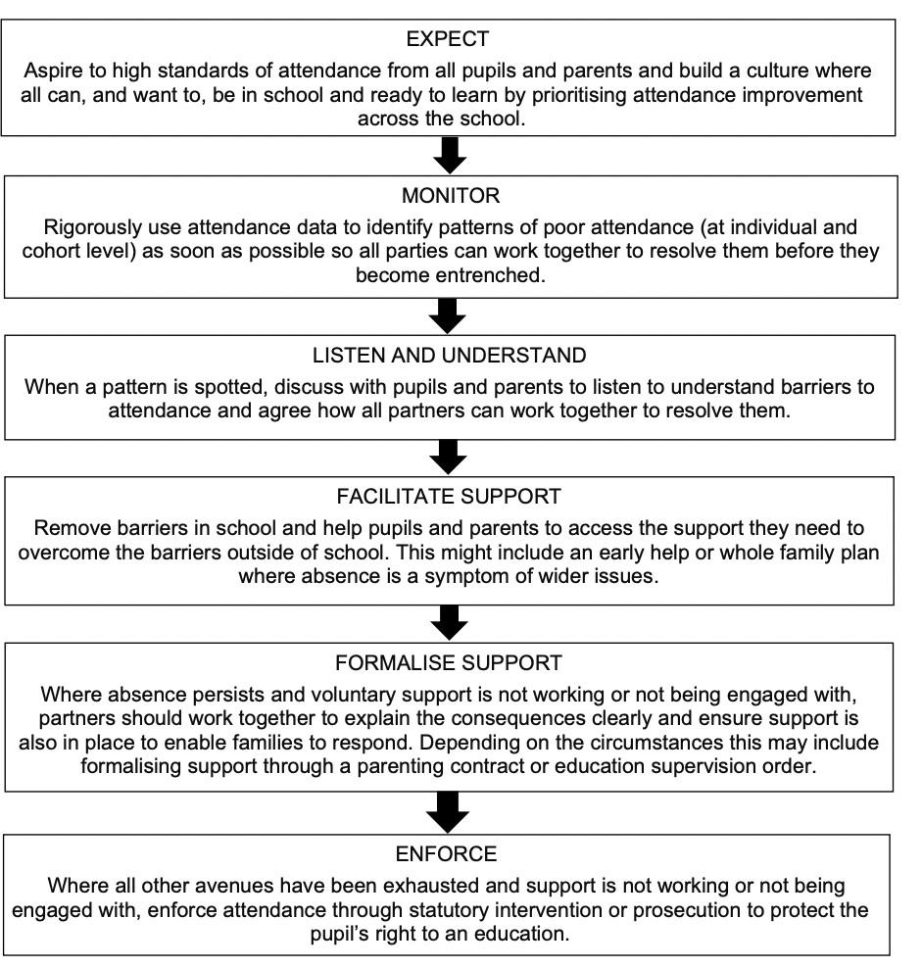

Appendix 1

Definition of Exceptional Circumstances Head Teachers may not grant any leave of absence during term time unless there are exceptional circumstances. Head Teachers should determine the number of school days a child can be away from school if the leave is granted. While leave of absence may be granted during term time, it is entirely at the Head Teacher’s discretion and it is not a parental right. Exceptional Circumstances The government and schools realise that is more expensive to go on holiday during the school holiday period than at other times of the year. However, it is the view of the DfE that a child(ren) should be in school for the 39 weeks of the academic year and that holidays in term time, in whatever form, are not considered to be ‘exceptional’ circumstances. Less expensive holidays are not a good enough reason for taking a child or young person out of school for two weeks. Absence from school under exceptional circumstances is slightly different from taking a holiday in term time. In deciding whether or not to grant a leave of absence for ‘exceptional circumstances’, the following examples may be considered:

* What is the normal pattern of attendance for the child(ren) who is asking for a leave of absence?
* What is ‘exceptional’ for one family might be the norm for another family. • Examples of ‘exceptional circumstances’ might include:
* A special one-off family event (30th wedding anniversary of grandparents; parents wedding)

- but one that doesn’t happen on an annual basis

* A funeral which requires the family to travel some distance etc
* The receipt of a special award which means the family need to travel some distance and stay overnight
* A parent who has the potential for a new job and wants to take their family with them to see if they like the area
* A parent who is in the Armed Forces might be considered under ‘exceptional’ circumstances, however, parents who have set holidays due to their work patterns are not considered to be ‘exceptional’ circumstances.

# Review - SPDC

Policy Ratified – October 2024 Ratification – October 2025

Appendix 1

**Slaley First School**

**REQUEST FOR LEAVE OF ABSENCE - DURING TERM TIME**

**Education (Pupil Registration) (England) Regulations 2006**

**Education (Pupil Registration) (England) (Amendment) Regulations 2013**

The 2013 amendments to the 2006 regulations explain clearly that Head Teachers may not grant any leave of absence during term time unless there are exceptional circumstances. Head Teachers should also determine the number of school days a child can be away from school if leave is granted.

| **Name of pupil** |  |
| --- | --- |
| **Date of birth** |  |
| **Address** |  |
| **Tutor/Year group** |  |
| **Contact Numbers** |  |
| **Name of sibling/s & school attended** |  |

I request permission for my child to be granted leave of absence from school between:-

| **First Day of Absence** |  |
| --- | --- |
| **Last Day of Absence** |  |
| **Total School Days** |  |

Please fully explain the **exceptional circumstances** relating to the leave of absence you would like the Head Teacher to consider. *(Continue on a separate sheet if necessary).*Any documentation supporting exceptional circumstances **MUST** be provided at the time of application



**Declaration**

I have read and understood the information regarding leave of absence during term time, unauthorised absence, Penalty Notices and prosecution. I am aware of the possible consequences should I take my child on leave of absence without the prior authorisation of the Head Teacher.

| **Name of parent** |  |
| --- | --- |
| **Date of birth** |  |
| **Address** |  |

| **Name of parent** |  |
| --- | --- |
| **Date of birth** |  |
| **Address** |  |

**Signature**……………………………………………… **Date**……………………

**Signature**……………………………………………… **Date**……………………

# Review - SPDC

Policy Ratified – October 2024 Next Ratification – October 2025