Slaley First School

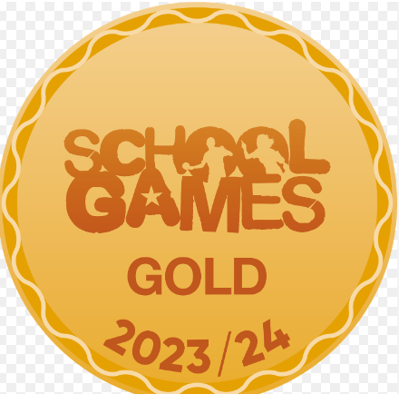



Pre-loved uniform will be on display on Tuesday 19th November at home time – Free to a good home!

**Roofworks**

**Roof Works are still ongoing so for now (until we hear otherwise) we will still be admitting all of the children through the main door.**

**Parents’ Evening**

**Parents Evening is on Thursday 21st November.**

**All initial letters were sent home yesterday, however if you didn’t receive one, I will attach one to this schoolcomms. Please can you return your preference slip by Monday 18th November**



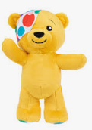

**Children In Need** On Friday next week (15th November) it is Children in Need and as per the

schoolcomms sent out earlier in the week we are hosting ‘**Slaley’s Got Talen**t’ where

children can perform a talent or skill to their friends (only if they want to!) If your child

would like to take part then please could they practice at home. **ALL CHILDREN CAN COME**

**TO SCHOOL DRESSED IN NON SCHOOL UNIFORM IF THEY WOULD LIKE TO.**

**Christmas …**

**Christmas Performances**

**Wednesday 11th December** – 9.20am

**Thursday 12th December** – 1.30pm

**Other Events**

**Friday 29th November 6pm-9pm** – Christmas Shopping Night

**Wednesday 4th December** (Time to be confirmed) Wreath Making in school

**Friday 6th December** – Christmas Coffee Morning

**Wednesday 11th December** 7pm-9pm Cake Decorating Night

**Tuesday 17th December** – Christmas Lunch and jumper day and Carols By

Candelight (Time to be arranged)

**Wednesday 18th December** (PM) Whole school trip to the Queen’s Hall Arts Centre to see ‘Jack and the Beanstalk.’

LAST DAY OF SCHOOL IS FRIDAY 20th December. We will be finishing at 1.30pm.



Friday 8th November 24

Dear Parents,

Another week over and another week closer to Christmas! Our Christmas practices for our performance will be underway very soon (we have already started to practice our songs.)

On Saturday 23rd November we are holding an Open Day for any prospective Early Years children and their families. If there is anyone that you feel may be interested, please can you let them know (there is a poster attached below.)



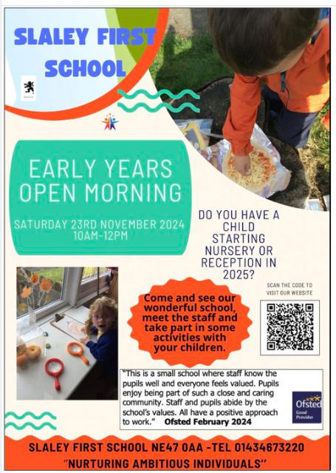

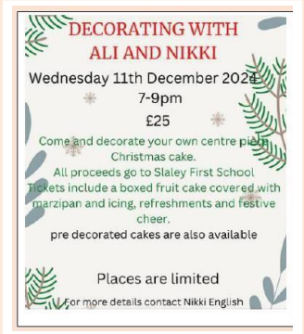 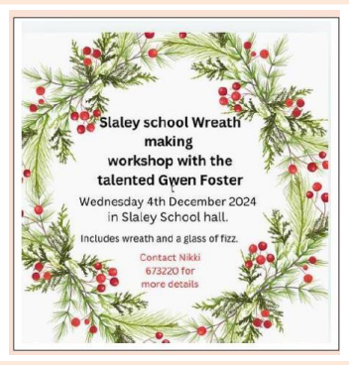

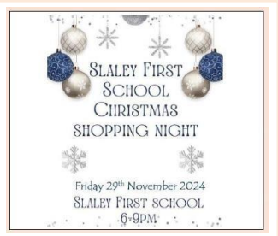

Tell your friends and family about our Christmas events …

Bring them along!

Have a lovely weekend!

Mrs Hayward