Slaley First School

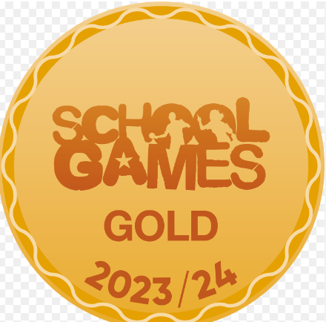

Friday 22nd November 24

**Roofworks**

**Roof Works are now signed off but we are expecting to have some new solar panels installed on the top of the roof, so it may be that we may need to have some more scaffolding errected soon.**

**Christmas …**

**Christmas Performances**

**Wednesday 11th December** – 9.20am

**Thursday 12th December** – 1.30pm

**Other Events**

**Friday 29th November 6pm-9pm** – Christmas Shopping Night

**Wednesday 4th December** (Time to be confirmed) Wreath Making in school

**Friday 6th December** – Christmas Coffee Morning

**Wednesday 11th December** 7pm-9pm Cake Decorating Night

**Tuesday 17th December** – Christmas Lunch and jumper day and Carols By

Candelight (Time to be arranged)

**Wednesday 18th December** (PM) Whole school trip to the Queen’s Hall Arts Centre to see ‘Jack and the Beanstalk.’

LAST DAY OF SCHOOL IS FRIDAY 20th December. School will close at 1.30pm.

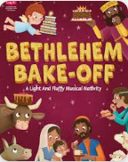





Dear Parents,

How cold has it been this week! Luckily our new heating system has kept us toastie warm in school. Thank you to those of you who came to Parents’ Evening last night, we had a great turn out. If you haven’t yet managed to book an appointment, we will be contacting you with one soon. Tomorrow we are holding an Open Day for any prospective Early Years children and their families. If there is anyone that you feel may be interested, please can you let them know (there is a poster attached below.)



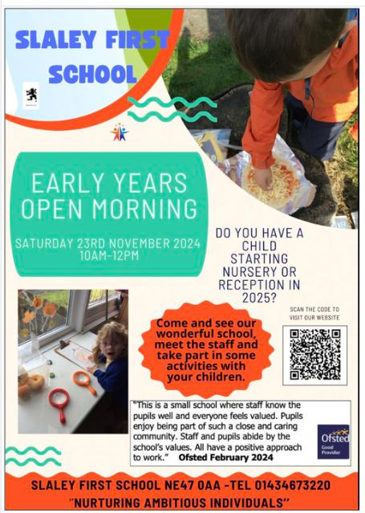

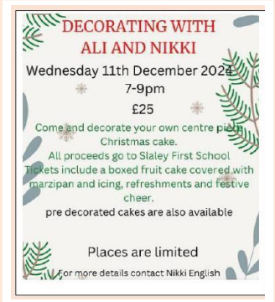 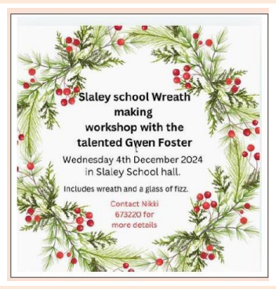

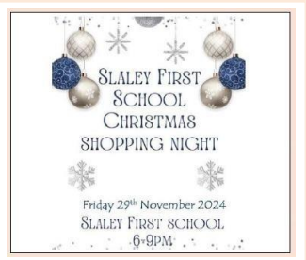

Tell your friends and family about our Christmas events …

Bring them along!

Have a lovely weekend!

Mrs Hayward