How to join Easy Fundraising
- Go to www.easyfundraising.org.uk and within the ‘join now’ box in the centre of the screen, search for ‘Friends of Slaley School’.
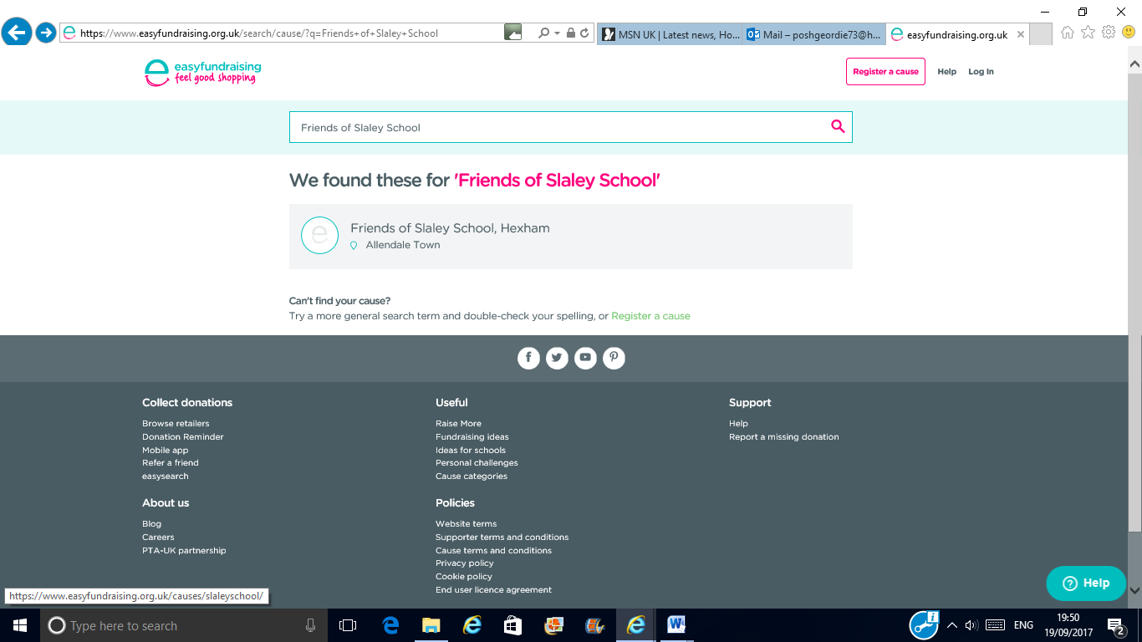
- As shown in the picture above, select ‘Friends of Slaley School, Hexham’ and this will take you to the next screen. (as shown below).

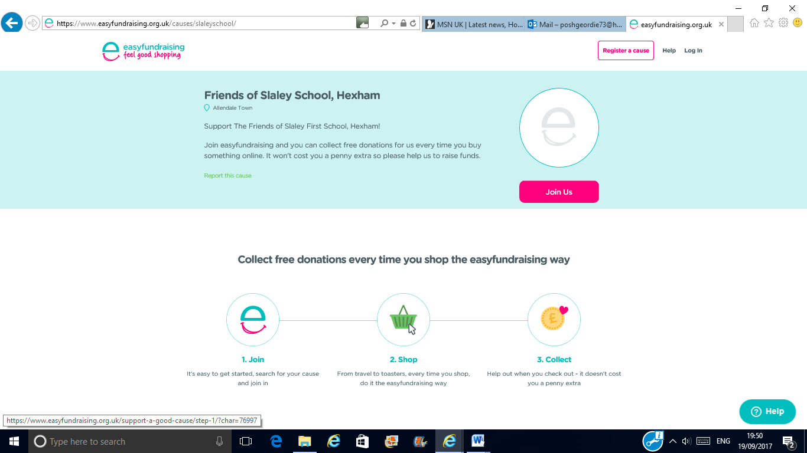
- Click on the ‘Join us’ button in pink which will take you to the create an account page.
- Please create your account
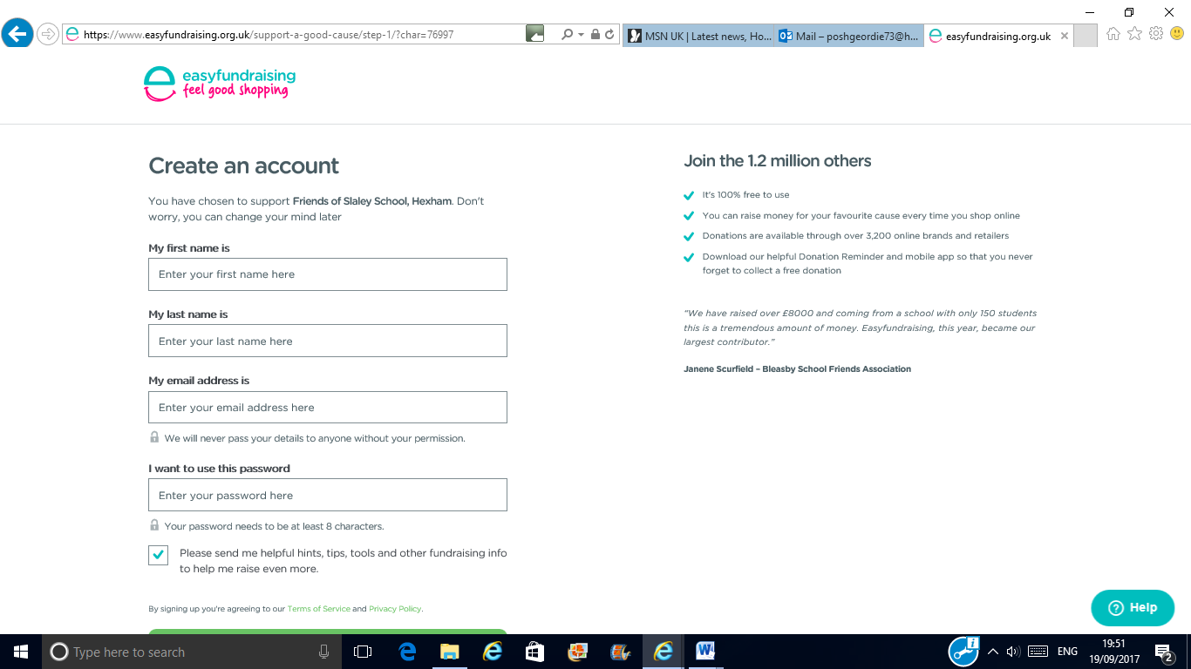

- Once you’ve created your account, you will see the page below.

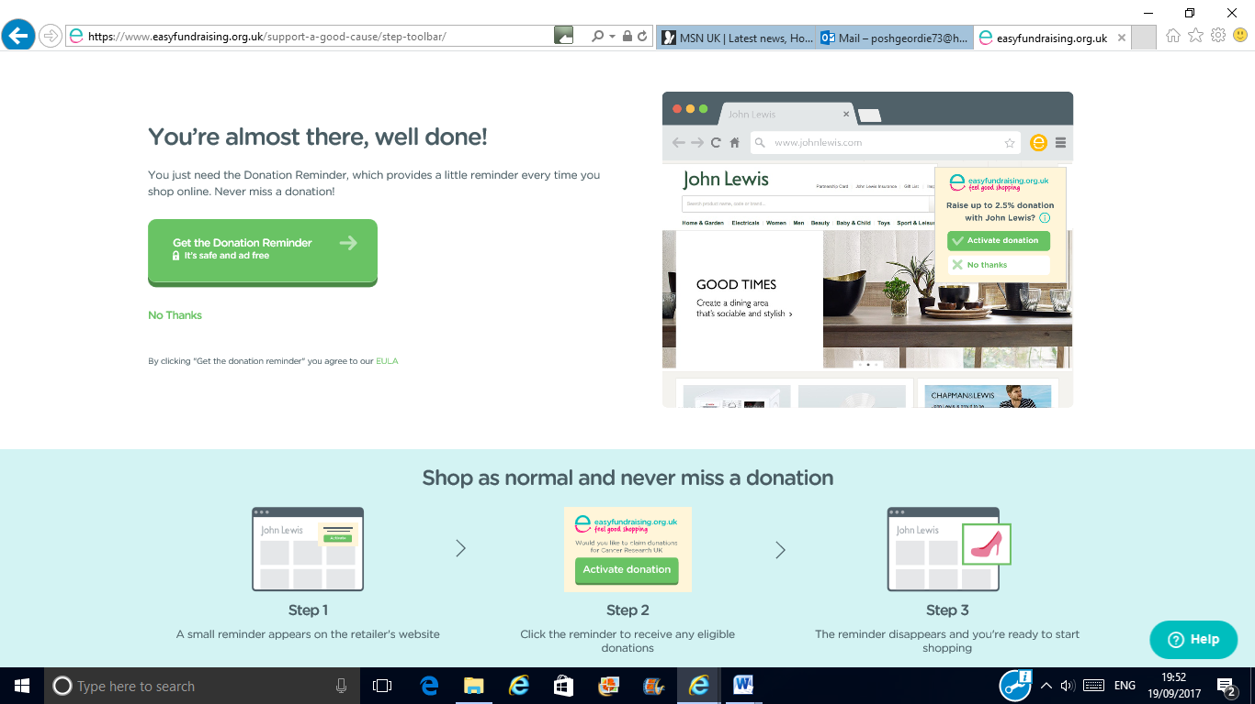
- Click on the ‘Get the Donation Reminder’ button in green. This provides a great reminder every time you shop on line!
This will install the donation reminder.
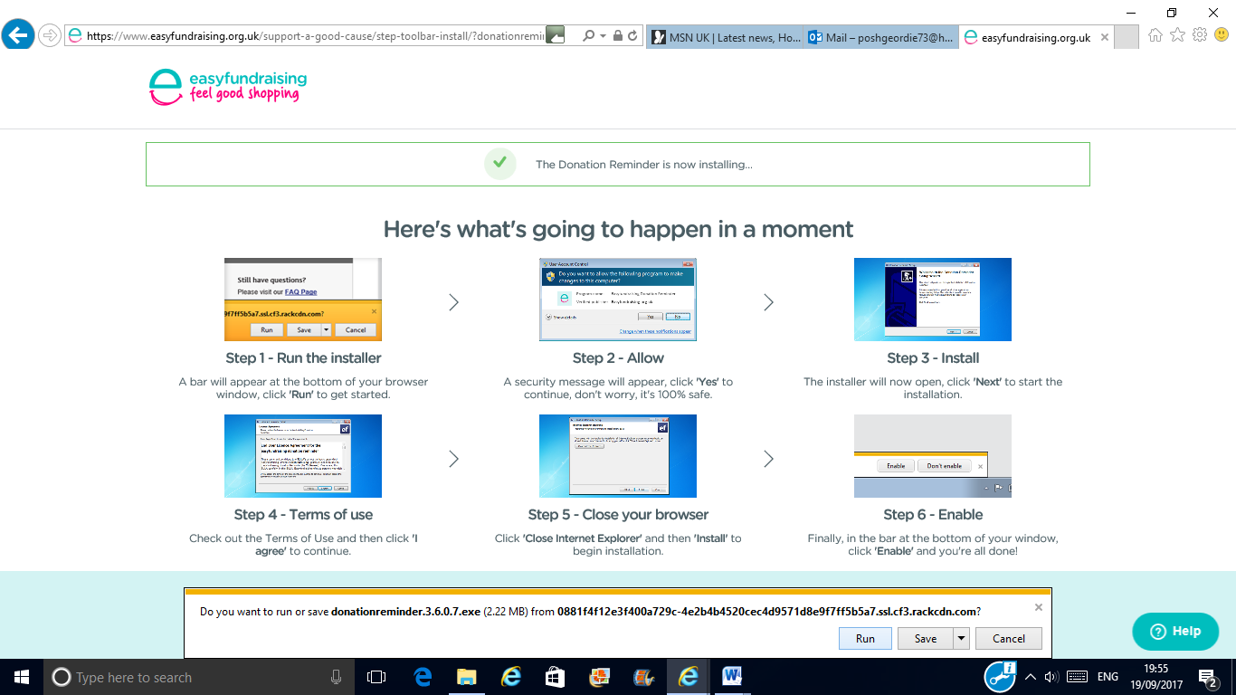
Please follow ALL the instructions as some browsers will need to be restarted as below.
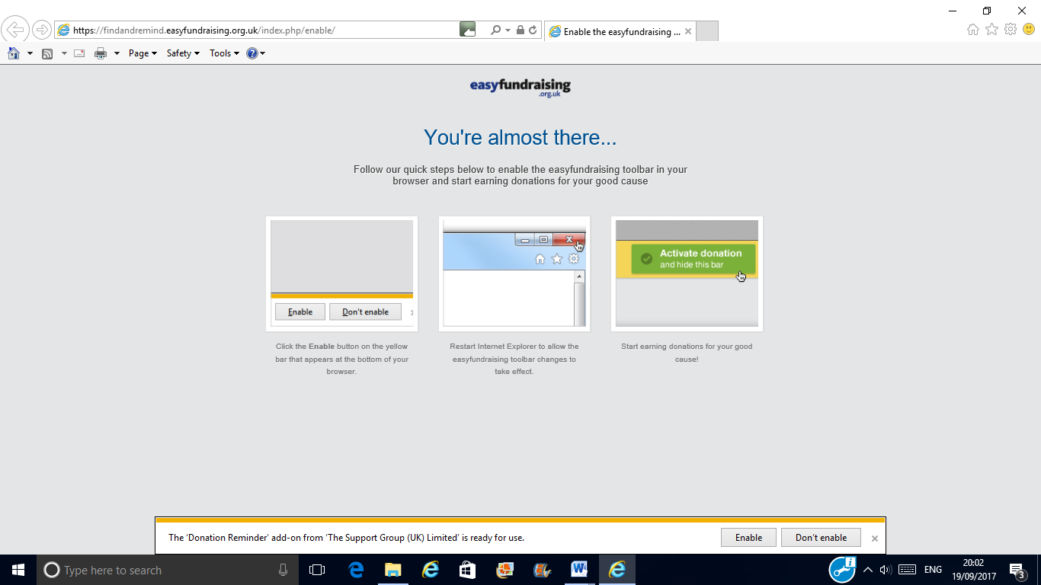
When you restart the browser and the reminder is installed you will see this screen. Simply press on the ‘OK, got it’ button. (as per the picture below).
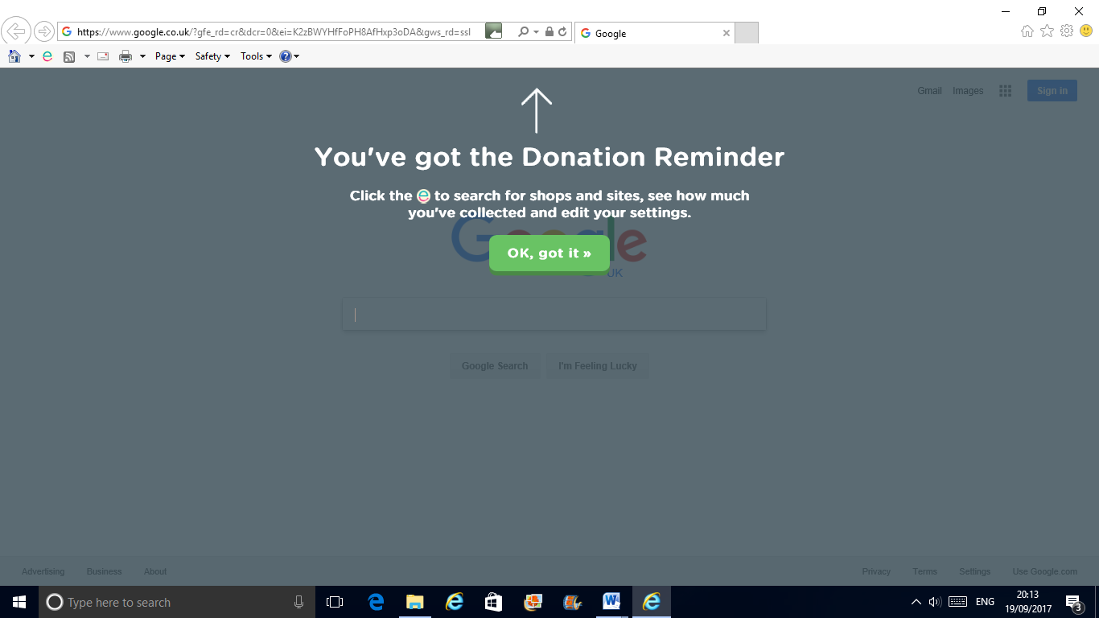
- You’re ready to go! Go shopping online!!
Please remember that you would need to click on the ‘active donation’ button in green on the top right hand corner of the webpage EVERYTIME you go to the webpage (as shown in the picture below).
In this instance, 2.5% of your purchase price would be donated to easy fundraiser and ultimately our Charity; Friends of Slaley School.
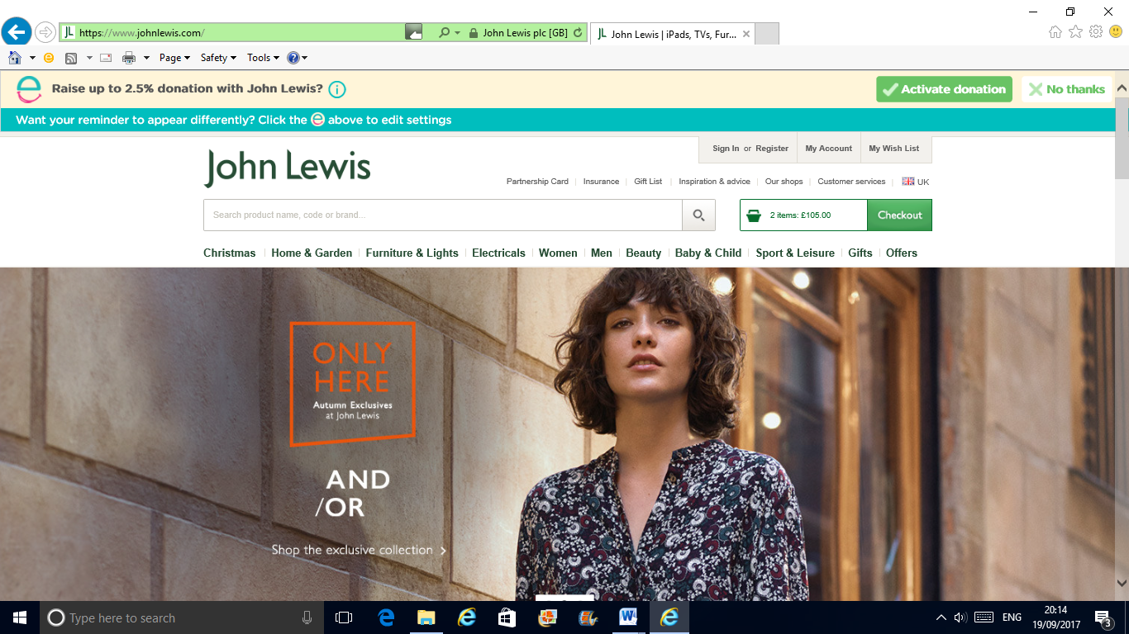
Note, you would need to install the ‘donation reminder’ on every device used to access the web however you can only install the ‘donation reminder’ on the following browsers: Chrome, Internet Explorer, Firefox and Safari.

