**Slaley First School**

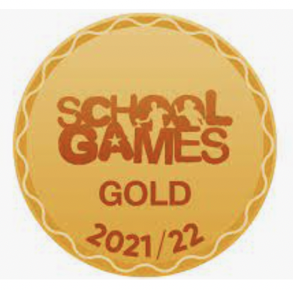

Little Reminders …

**PE Kit**

Dear Parents/Carers,

What beautiful weather we have had this week and how lucky we are to be in beautiful Slaley to enjoy it!

First of all, I have some wonderful news to share with you all! We are all very excited because Mrs Ainslie has had her baby!!! She has had a gorgeous little boy and has named him Reuben! How wonderful – he is absolutely gorgeous and mother and baby are doing well!

Yesterday our Class 1 children were involved in a ‘Commonwealth Games Event’ at Wentworth Gym and they all had an amazing time – Check out the website as there will be some photos on there soon. Today our Yr 4 children were invited to the Queen Elizabeth High School in Hexham and they took part in a ‘Community Cohesion’ Event with other children form other schools. Mrs English said all of the children were impeccably behaved and she was very proud of them all.

As mentioned on Schoolcomms yesterday, we have been working hard as a staff to re-write our curriculum to make it more progressive. I have uploaded most long-term plans onto the website for you to see and these will be always available so you can see what your child will be learning at school. We will also be sending out bulletins from next term which show what we are learning each half term. Finally, we have some transition evenings coming up for. I will let you know more about these next week.

This week we have had the return of the dreaded COVID-19, we have made some slight amendments to the day as a result but have also been keen to carry on as normal within the realms of the guidance.

Have a lovely weekend! Mrs Hayward

Today in school we have been celebrating **European Languages Day** and Mrs Seymour made us a fabulous Spanish themed lunch which we enjoyed very much. We have also been partaking in some Spanish activities including dancing and exploring castanets!

Watch Me Grow

**Friday 24th June 2022**

This

PE Kits

PE Kits (preferably consisting of: yellow t-shirt, blue shorts, blue sweatshirt & jogging bottoms, trainers, spare socks) are required for all pupils to be brought in on a Monday and left in school and taken home on a Friday. All items must be clearly labelled with your child’s name. Uniform can be ordered online from Salto UK Ltd.

Please note, hoodies have been discontinued due to health & safety reasons.

